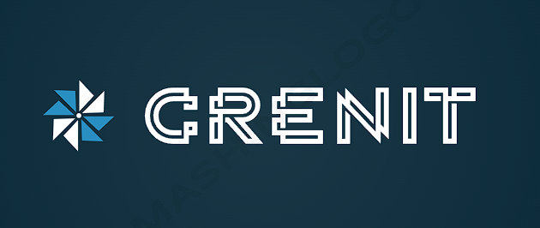

Project Plan

Team CreniT

QuizzTurn

*Clients:*

Prof. Tim Kurvers

<https://git.fhict.nl/I477163/individual-project.git>

September 6, 2023

Table of Contents

1.Introduction 2

2.Involved Parties 3

2.1 Client 3

2.2 Team 3

3. Current situation 3

4. Project Scope 4

4.1 Problem 4

4.2 Goal 4

5. Deliverables 4

5.1 Deliverables 4

5.2 non-Deliverables 5

6. Constraints 5

7. Planning 5

# 1.Introduction

This is the project plan of team CreniT, class S3-CB04, for the project QuizzTurn. In the following document we will outline all important aspects of the project specifications: from the management of all quizzes to the user data. We will showcase the existing problem in the company and give our solutions. A chart will be shown, so the client can easily understand the teams planning for the sixteen weeks. The contacts of both the client and the members of the team will be also present in the document.

# 2.Involved Parties

## 2.1 Client

The client of this project is QuizzTurn. The representative is Tim Kurvers

## 2.2 Team

The CreniT team consist of 1 ICT-student from Fontys University of Applied Sciences in Eindhoven,

**Details of the member:**

Petar Dakov

p.dakov@student.fontys.nl   
4423208

# 3. Current situation

The client is requesting the creation of a web application and a management system that will help them manage the everyday operations. They want to get more information about their users and the content they prefer to watch and enjoy.

# 4. Project Scope

## 4.1 Problem

Currently the QuizzTurn is having difficulties with understanding what their users want to see from them in the future. Our client is reaching out to us to create a website where it is easy for the users to communicate with each other and answer questions that are made from them or the company.

## 4.2 Goal

For this project, the goal is to come up with a software solution that ensures the management of users and quizzes as the main priority.

The management of everything will be mostly done with basic CRUD functionality. The users will be able to communicate with each other and play many different quizzes.

# 5. Deliverables

## 5.1 Deliverables

With all the provided information, we will implement a website for quizzes.

**The following will be delivered to the client at the end of the project:**

- Documentation: Project Plan, URS, Test Plan

- Web Application: being able to create quizzes, use a chat system with other users, answer questions made by other users.

- UML Class Diagram

## 5.2 non-Deliverables

The non-deliverables are the elements of the project that will not be provided by Team CreniT, which the client must acquire on their own.

**The non-deliverables for the project are the following:**

- Hardware for the project.

# 6. Constraints

This project has some boundaries. That are meant to give the project a boundary that makes it clear what the project group will provide for the client.

• We will be creating a software solution using .NET Framework as backend ( C# ), with this language we will be working in razor pages.

• The frontend language will be React.

• The database will be MySQL.

• By the end of the semester we will have to hand the finished project.

# 7. Planning

* This chart shows how the work is divided by sprints. It has 5 sprints starting from week 2 with different content.